Format Your Paper as Per the Following Template
(16 Times New Roman)

1st Author’s full name,
College name, University, Country
Insert e-mail here
and
2nd Author’s full name,
College name, University, Country
Insert e-mail here
3rd Author’s full name,
College name, University, Country
Insert e-mail here
……….so on……

Abstract: Insert your abstract here. The abstract of the paper should summarize the scope, aims, results and conclusions of the work. Abstract should include approximately 200 -300 words.

Keywords: these are your keywords, put at least 4 - 6 keywords

1. Introduction
Length of your full paper should be no less than 8 pages and no more than 20 pages. Follow this template in all sections as a standard. The purpose of a paper is to communicate new scientific results or technical innovations with a scientific underpinning. Start the paper with an introduction, and clearly state the purpose/goal of the work. Provide the reader with the context of the work and show relevance and usefulness. Indicate the state-of-the-art by making adequate references to related previous publications in the scientific field. The paper should clearly describe the methods and/or tools as developed or applied in the work. Describe the results in a concise fashion and finish the paper with conclusions and recommendations.
If the paper describes the design or operational performance of a system, point out the general value to be gained from the work. If a case study is presented, the merits of the particular case must be emphasized. A case research involving an open or closed ended issues should provide detailed examination of a subject of study and related contextual conditions. The case study research may follow formal research method. If it is an experimental work, describe the experimental design setup, data collection methods, data verification, data reliability, data validation methods and scientific analysis to describe the field of research. For a theory based work, describe the hypothesis, conceptual framework supported by proof or other methodologies that advances the knowledge in the discipline. Theory based research paper should include four basic criteria: conceptual definitions, relationship-building, domain limitations, and predictions. Theory-building is important and is needed for the applicability to practical real world problems.

It is strongly recommended that the paper is structured with the following sections: introduction/objectives, Literature review, methods, research Design, Results/Salient features of research, new or breakthrough aspect, conclusions, references, Author Introduction.

2. Section headings
This is an example of section heading.
Declaration Statement for the Originality of the Research Work: All submitted manuscript must have a declaration statement for the originality of the research work and have not been submitted for publications elsewhere or previously published.
Margins: All margins must be 2.6 (≈1”) cm on all sides.
Font: The font of the text material must be12-point Times New Roman. (You follow this template)
Line Spacing: The text material must use 1.25 lines spacing. The reference section should contain line spacing as 1.
Line Justification: All parts of the paper (except the title page) must use full justification.
Title Page and Main body of the paper: The main body of the paper should contain title, author information, abstract and entire contents.
Headings: All major headings (and subheadings) must be formatted to stand out from the body text and must have a type size of 12-point and bold. All minor sub-headings must be formatted to stand out from the body text and must have a type size of 12-point bold font.

2.1 Section subheadings
This is an example of section subheading.
Page Numbers: All pages are to be numbered consecutively and centered within a footer at the bottom of each page, beginning with page 1 on the first page of text after the title page.

Tables, Figures, Graphs and Drawings: All tables, figures, graphs and drawings are to be numbered consecutively using Arabic numerals (1, 2, 3, etc.). A title is to appear after the number and the entire label is to appear under the figure, graph or drawing and on top of the table. Use Times New Roman font with size 10 for figures and table captions.

3. Illustrations and Tables

3.1 General
Illustrations and tables should be originals or sharp prints. All illustrations, both line art and photographs, should be placed in position on or near the page where they are first mentioned or treated in detail. They should preferably be placed either at the top or at the bottom of the page.

3.2 Tables
Centre tables. Set table number and title (normal, 10 point) justified above table adjusting text to table width. Horizontal lines should be placed above and below table headings, above the subheadings and at the bottom of the table above any notes. Vertical lines should be avoided.
Table 1. Example of a Table: Caption should be placed above the table. Use style and adjust text to table width.
 | Pilot plant |  |  | Full scale plant
 | Influent | Effluent |  | Influent | Effluent
Method-C cyanide | 4.1 | 0.05 |  |  | 0.02
Thiocyanide | 60.0 | 1.0 |  | 50.0 | <0.10
Ammonia | 6.0 | 0.50 |  | 0.10
Copper | 1.0 | 0.04 |  | 1.0 | 0.05
Suspended solids |  |  |  |  | <10.0

3.3 Figures

Figures and images should be centered. Figure captions should be placed below each illustration, font Times New Roman, Normal, 10 points, leaving approx. 6 points between caption and text and 6 points between text and top of the figure.
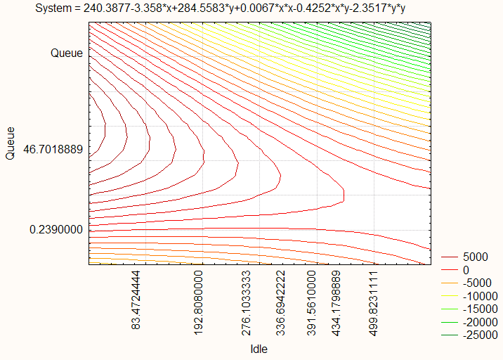

Figure 1. Example of a Figure: Use style and adjust text to figure width.

4. References

Author are required to follow the IEEE citation styles. The following are some examples:

Reference to a journal publication:

[1] J. Van der Geer, J.A.J. Hanraads, R.A. Lupton, The art of writing a scientific article, J. Sci. Common. 163 (2010) 51–59.

Reference to a book:
[2] W. Strunk Jr., E.B. White, The Elements of Style, fourth ed., Longman, New York, 2000.

Reference to a chapter in an edited book:
[3] G.R. Mettam, L.B. Adams, How to prepare an electronic version of your article, in: B.S. Jones, R.Z. Smith (Eds.), Introduction to the Electronic Age, E-Publishing Inc., New York, 2009, pp. 281–304.

Reference to a website:
[4] Cancer Research UK, Cancer statistics reports for the UK. http://www.cancerresearchuk.org/aboutcancer/statistics/cancerstatsreport/, 2003 (accessed 13 March 2003).

